Project ideas:

* **Login page –**

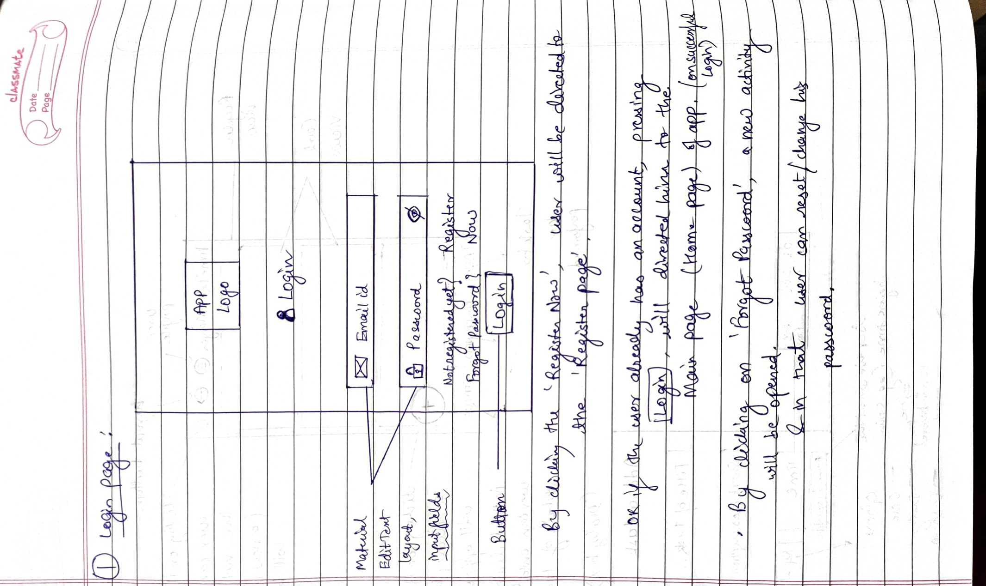

* Using material text input layouts, the password toggle feature can be added.
* Upon successful login, a toast will be shown as ‘Login Successful!’
* **Register page:**
* I will also add checks in both login and register page. i.e., if user leaves any of the input fields blank, he will be shown an error message as ‘Email is mandatory’/ ‘Password is mandatory’.

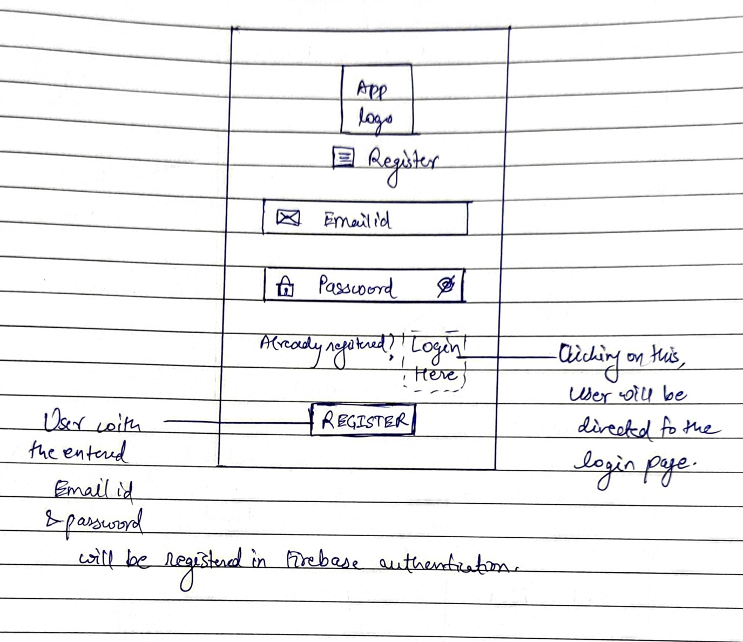

* Upon successful registration, a toast will be shown as ‘Registration Successful!’ and user will be directed to the main page of the app.